Note: Include this page only when adding / amending / deleting a document. If using this document as a record, this Revision History page can be omitted.

REVISION HISTORY

Revision no | Date | Description of Changes | Reason for Revision | Revised by | Approved by
1 | 19 Apr 13 | - Add revision history page | - Recommendation from Stage 2 audit | RDPlacido
2 | 9 Nov 2015 | - Added Disclaimer | - Printing is sole responsibility of the person who printed it | RCGanal | ECVentura

- Objective

To meet the members of the board and discuss the following:
- company's performance & how it is achieving its vision
- issues on major investments, new projects, risks, targets, budgets, people, clients, etc.

- Scope

This procedure defines the responsibilities of the board members, which include the discussion of financial performance, business plan, strategies and other matter which need the support/advice of the board members. This procedure also presents when and how board meetings are conducted.

- Definition of Terms

None

- Procedure Details

RESPONSIBLE | ACTIVITY | INTERFACE
Corporate Secretary  Board Members  Corporate Secretary | 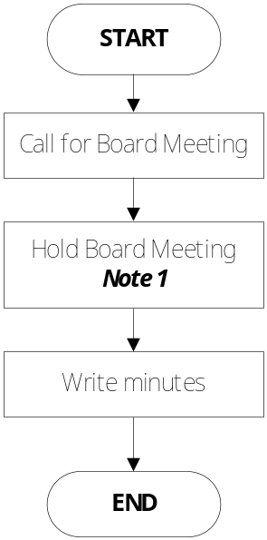 | Board Meeting Agenda  Financial Statements  Board Meeting Minutes

Notes:

- CPI's board meetings are informal, they are held every quarter. Meeting starts with the review and approval of the previous meeting's minutes, followed by the review and discussion of the financial statements. Closed accounts within the quarter as well as prospective accounts are presented. Views are exchanged on strategies to close prospective accounts, possible new projects & services, plans for the future, approval of budgets and major expenses. The corporate secretary and the treasurer will keep one copy each of the following:
- signed copy of the minutes
- Financial Statements
- Agenda

- References
- Board Meeting Agenda Template
- Board Meeting Minutes Template
- Financial Statements

- Quality Records

- Board Meeting Agenda
- Board Meeting Minutes
- Financial Statements

